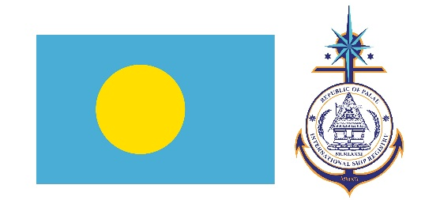 | APPLICATION FOR MINIMUM SAFE MANNING
 | Europe Head Office  5, Sachtouri Street  Piraeus, Greece,  18536, 6th floor  T: +30 210 4293500  F: +30 210 4293505 | USA Head Office  The Woodlands, TX, 77380 9595 Six Pines Drive,  Suite 8210, Office 277  T: +1 832 631 6061  F: +1 832 631 6001
All ships registered in Palau of 100 tones Gross Tonnage and above and all passenger ships of any size are required to carry to Minimum Safe Manning Certificate. Applicants should pay attention to the Minimum Manning Requirements as per Marine Notice (MN-184).

part 1. owner/operator details
Owner Name:
Operating Company Name:
Operator Point of Contact:
Address:
Town/City
Country
Post/Zip Code
Telephone
Fax
Email
Operator IMO Number:

part 2. vessel particulars
Present Ship Name:
Previous Ship Name: |  |  | Official Number:
IMO Number: |  |  | Vessel Type:
Gross Tonnage: |  |  | Net Tonnage:
Total Propulsion Power: |  |  | Total Generators Power:
Type of Propulsion: | ☐ Steam / ☐ Motor
Number of Engines: |  |  | Number of Lifeboats:
Number of Fast Rescue Boats: |  |  | Number of Liferafts:
Classification Society:
Recognized Organization:
UMS Operations: | ☐ Yes / ☐ No | If Yes, indicate UMS Class Notations:

part 3. trading status
☐ International |  | ☐ Laid Up
☐ Near Coastal Area: |  | ☐ Under Repairs
☐ Domestic Coastal, Area: |  | ☐ Under Tow
Intended GMDSS Sea Areas in which the ship will sail: |  | ☐ A1 | ☐ A2 | ☐ A3 | ☐ A4

part 4. minimum manning propossal by the owner
The proposal shall consider IMO Assembly resolution A.1047(27) and will be reviewed by Palau International Ship registry and a Minimum Manning Certificate will be issued under the authority of the Marine Notice 184, subject to all necessary information requested being provided. Proposals or requests for reduced manning should be attached to this application by filling up the below table and with complete support documentation, including a justification letter and occasionally risk assessment referring to the operation of the vessel with the reduced manning, may be required.

Deck |  | Engine
Capacity/Regulation | No. of Persons | Capacity/Regulation | No. of Persons
Master (II/2) |  | Chief Engineer (III/2)
Master (II/3) |  | Chief Engineering (III/3)
Chief Mate (II/2) |  | Second Engineering (III/2)
Chief Mate (II/3) |  | Second Engineering (III/3)
Navigational Watch Officer (II/1) |  | Engineering Watch Officer (III/1)
Able Seafarer Deck (II/5) |  | Able Seafarer Engine (III/5)
Rating Forming Part of Navigational Watch (II/4) |  | Rating Forming Engine Watch (III/4)
GMDSS Operator
Ship Security Officer
Tanker Familiarization
Passenger Vessel
Cook
Electro-Technical

Part 5. OATH and declaration
I,
Do hereby swear and affirm, that I am duly authorized to sign this application by the Article of incorporation as Director or in writing by a Power of Attorney by the Ship-Owner(s), Bareboat Charters or prospective Ship-Owners(s), Bareboat Charters and declare that all information contains herein are true and correct.
Name:
Title:
Citizen Of:
Passport Number:
Signature |  |  | Date

ACKNOWLEDGEMENT

Subscribed and Sworn Before me
Day
Month
Year |  | Signature and Seal of Notary Public or by an Officer at Palau International Ship Registry Head Quarters or by an Authorized Deputy Registrar to Palau International Ship Registry.
Place

Scan to download this  application form | APPLICATION FOR MINIMUM SAFE MANNING
 | Europe Head Office  5, Sachtouri Street  Piraeus, Greece,  18536, 6th floor  T: +30 210 4293500  F: +30 210 4293505 | USA Head Office  The Woodlands, TX, 77380  9595 Six Pines Drive,  Suite 8210, Office 277  T: +1 832 631 6061  F: +1 832 631 6001
 | 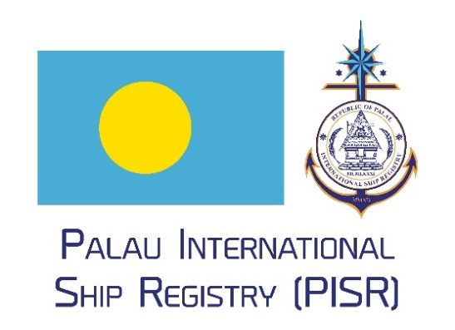

Owner and operator details
Name of the vessel’s registered owner
Name of the vessel’s operator
Operator contact person
Vessel operator address details
Operator’s IMO Company Number
Name that vessel as registered under Palau Flag
Previous vessel name, prior to the registration under Palau Flag
Vessel’s Official Number, if assigned
Vessel IMO Number
Vessel type as per Class Certificate, Class Statement, or Confirmation of Class
As per International Tonnage Convention 1969
As per International Tonnage Convention 1969
Maximum main propulsion power in Kilo Watts
Maximum main propulsion power in Kilo Watts
Indicate if the propulsion type is steam or motor
Indicate the number of main propulsion engines
Indicate the number of total lifeboats
Indicate the number of fast rescue boats
Indicate the total number of liferafts
Indicate the vessel’s intended Classification Society while register under Palau flag
Indicate the vessel’s intended Recognized Organization while registered under Palau flag
Indicate if the vessel has periodically Unattended Machinery Spaces
Indicate if the vessel is in laid-up status, give details of laid-up geographical position, including a copy of the Class Certificate showing the laid-up status.
Voyages within 200nm from ashore and no more of 200 nm from the last port of call. If restricted give details of trading area, including any conditions imposed by Class on the sailing area/sea conditions. In such instance, a copy of the Class Certificate showing the restrictions should be attached.
Indicate if the vessel will be under repairs
Voyages within 20nm from ashore and no more than 200 nm from the last port of call; give details of trading area, including any conditions imposed by Class on the sailing area/sea conditions. In such instance, a copy of the Class Certificate showing the restrictions should be attached
Indicate if the vessel intends under tow sailing.
Applicable for ships over 300GT

